**Scema Design:**

**Create Database**

**CREATE DATABASE Institute_Management_System;**

**USE Institute_Management_System;**

**Create Users Table**

**CREATE TABLE Users (**

**user_id INT AUTO_INCREMENT PRIMARY KEY,**

**username VARCHAR(50) UNIQUE NOT NULL,**

**password_hash VARCHAR(255) NOT NULL, -- Hashed password using bcrypt**

**email VARCHAR(100) UNIQUE NOT NULL,**

**role ENUM('admin', 'faculty', 'student') NOT NULL,**

**created_at TIMESTAMP DEFAULT CURRENT_TIMESTAMP,**

**updated_at TIMESTAMP DEFAULT CURRENT_TIMESTAMP ON UPDATE CURRENT_TIMESTAMP**

**);**

**Create Students Table**

**CREATE TABLE Students (**

**student_id INT AUTO_INCREMENT PRIMARY KEY,**

**user_id INT UNIQUE NOT NULL,**

**name VARCHAR(100) NOT NULL,**

**contact_number VARCHAR(15),**

**address TEXT,**

**enrollment_date DATE NOT NULL,**

**FOREIGN KEY (user_id) REFERENCES Users(user_id) ON DELETE CASCADE**

**);**

**Create Faculty Table**

**CREATE TABLE Faculty (**

**faculty_id INT AUTO_INCREMENT PRIMARY KEY,**

**user_id INT UNIQUE NOT NULL,**

**name VARCHAR(100) NOT NULL,**

**contact_number VARCHAR(15),**

**department VARCHAR(100) NOT NULL,**

**FOREIGN KEY (user_id) REFERENCES Users(user_id) ON DELETE CASCADE**

**);**

**Create Courses Table**

**CREATE TABLE Courses (**

**course_id INT AUTO_INCREMENT PRIMARY KEY,**

**course_code VARCHAR(20) UNIQUE NOT NULL,**

**course_name VARCHAR(100) NOT NULL,**

**description TEXT,**

**credits INT NOT NULL,**

**faculty_id INT, -- Assigned faculty**

**FOREIGN KEY (faculty_id) REFERENCES Faculty(faculty_id) ON DELETE SET NULL**

**);**

**-- Create Student_Courses Table**

**CREATE TABLE Student_Courses (**

**student_course_id INT AUTO_INCREMENT PRIMARY KEY,**

**student_id INT NOT NULL,**

**course_id INT NOT NULL,**

**enrollment_date DATE NOT NULL,**

**status ENUM('enrolled', 'completed') DEFAULT 'enrolled',**

**FOREIGN KEY (student_id) REFERENCES Students(student_id) ON DELETE CASCADE,**

**FOREIGN KEY (course_id) REFERENCES Courses(course_id) ON DELETE CASCADE**

**);**

**-- Create Attendance Table**

**CREATE TABLE Attendance (**

**attendance_id INT AUTO_INCREMENT PRIMARY KEY,**

**student_id INT NOT NULL,**

**course_id INT NOT NULL,**

**date DATE NOT NULL,**

**status ENUM('present', 'absent') NOT NULL,**

**FOREIGN KEY (student_id) REFERENCES Students(student_id) ON DELETE CASCADE,**

**FOREIGN KEY (course_id) REFERENCES Courses(course_id) ON DELETE CASCADE**

**);**

**-- Create Grades Table**

**CREATE TABLE Grades (**

**grade_id INT AUTO_INCREMENT PRIMARY KEY,**

**student_id INT NOT NULL,**

**course_id INT NOT NULL,**

**grade VARCHAR(2) NOT NULL,**

**remarks TEXT,**

**FOREIGN KEY (student_id) REFERENCES Students(student_id) ON DELETE CASCADE,**

**FOREIGN KEY (course_id) REFERENCES Courses(course_id) ON DELETE CASCADE**

**);**

**-- Create Examinations Table**

**CREATE TABLE Examinations (**

**exam_id INT AUTO_INCREMENT PRIMARY KEY,**

**course_id INT NOT NULL,**

**exam_date DATE NOT NULL,**

**duration INT NOT NULL, -- Duration in minutes**

**total_marks INT NOT NULL,**

**FOREIGN KEY (course_id) REFERENCES Courses(course_id) ON DELETE CASCADE**

**);**

**-- Create Fee_Structure Table**

**CREATE TABLE Fee_Structure (**

**fee_structure_id INT AUTO_INCREMENT PRIMARY KEY,**

**fee_type VARCHAR(50) NOT NULL, -- e.g., Tuition, Library, Lab**

**amount DECIMAL(10, 2) NOT NULL,**

**description TEXT**

**);**

**-- Create Fee_Payments Table**

**CREATE TABLE Fee_Payments (**

**payment_id INT AUTO_INCREMENT PRIMARY KEY,**

**student_id INT NOT NULL,**

**fee_structure_id INT NOT NULL,**

**payment_date DATE NOT NULL,**

**amount_paid DECIMAL(10, 2) NOT NULL,**

**status ENUM('paid', 'pending') DEFAULT 'pending',**

**FOREIGN KEY (student_id) REFERENCES Students(student_id) ON DELETE CASCADE,**

**FOREIGN KEY (fee_structure_id) REFERENCES Fee_Structure(fee_structure_id) ON DELETE CASCADE**

**);**

**-- Create Timetable Table**

**CREATE TABLE Timetable (**

**timetable_id INT AUTO_INCREMENT PRIMARY KEY,**

**course_id INT NOT NULL,**

**faculty_id INT NOT NULL,**

**room VARCHAR(50) NOT NULL,**

**day ENUM('Monday', 'Tuesday', 'Wednesday', 'Thursday', 'Friday', 'Saturday', 'Sunday') NOT NULL,**

**start_time TIME NOT NULL,**

**end_time TIME NOT NULL,**

**FOREIGN KEY (course_id) REFERENCES Courses(course_id) ON DELETE CASCADE,**

**FOREIGN KEY (faculty_id) REFERENCES Faculty(faculty_id) ON DELETE CASCADE**

**);**

**-- Create Notifications Table**

**CREATE TABLE Notifications (**

**notification_id INT AUTO_INCREMENT PRIMARY KEY,**

**user_id INT NOT NULL,**

**message TEXT NOT NULL,**

**created_at TIMESTAMP DEFAULT CURRENT_TIMESTAMP,**

**is_read BOOLEAN DEFAULT FALSE,**

**FOREIGN KEY (user_id) REFERENCES Users(user_id) ON DELETE CASCADE**

**);**

**-- Insert data into Users Table**

**INSERT INTO Users (username, password_hash, email, role) VALUES**

**('admin01', 'hashed_password_1', 'admin@example.com', 'admin'),**

**('faculty01', 'hashed_password_2', 'faculty@example.com', 'faculty'),**

**('student01', 'hashed_password_3', 'student@example.com', 'student');**

**-- Insert data into Students Table**

**INSERT INTO Students (user_id, name, contact_number, address, enrollment_date) VALUES**

**(3, 'John Doe', '1234567890', '123 Street, City', '2023-09-01');**

**-- Insert data into Faculty Table**

**INSERT INTO Faculty (user_id, name, contact_number, department) VALUES**

**(2, 'Dr. Smith', '0987654321', 'Computer Science');**

**-- Insert data into Courses Table**

**INSERT INTO Courses (course_code, course_name, description, credits, faculty_id) VALUES**

**('CS101', 'Introduction to Programming', 'Basic programming concepts', 3, 1),**

**('CS102', 'Data Structures', 'Fundamentals of data structures', 4, 1);**

**-- Insert data into Student_Courses Table**

**INSERT INTO Student_Courses (student_id, course_id, enrollment_date, status) VALUES**

**(1, 1, '2023-09-05', 'enrolled');**

**-- Insert data into Attendance Table**

**INSERT INTO Attendance (student_id, course_id, date, status) VALUES**

**(1, 1, '2023-09-06', 'present');**

**-- Insert data into Grades Table**

**INSERT INTO Grades (student_id, course_id, grade, remarks) VALUES**

**(1, 1, 'A', 'Excellent performance');**

**-- Insert data into Examinations Table**

**INSERT INTO Examinations (course_id, exam_date, duration, total_marks) VALUES**

**(1, '2023-12-01', 120, 100);**

**-- Insert data into Fee_Structure Table**

**INSERT INTO Fee_Structure (fee_type, amount, description) VALUES**

**('Tuition', 5000.00, 'Semester tuition fee'),**

**('Library', 500.00, 'Library maintenance fee');**

**-- Insert data into Fee_Payments Table**

**INSERT INTO Fee_Payments (student_id, fee_structure_id, payment_date, amount_paid, status) VALUES**

**(1, 1, '2023-09-10', 5000.00, 'paid');**

**-- Insert data into Timetable Table**

**INSERT INTO Timetable (course_id, faculty_id, room, day, start_time, end_time) VALUES**

**(1, 1, 'Room 101', 'Monday', '09:00:00', '10:30:00');**

**-- Insert data into Notifications Table**

**INSERT INTO Notifications (user_id, message, created_at, is_read) VALUES**

**(3, 'Welcome to the Institute!', NOW(), FALSE);**

**E-R Diagram:**

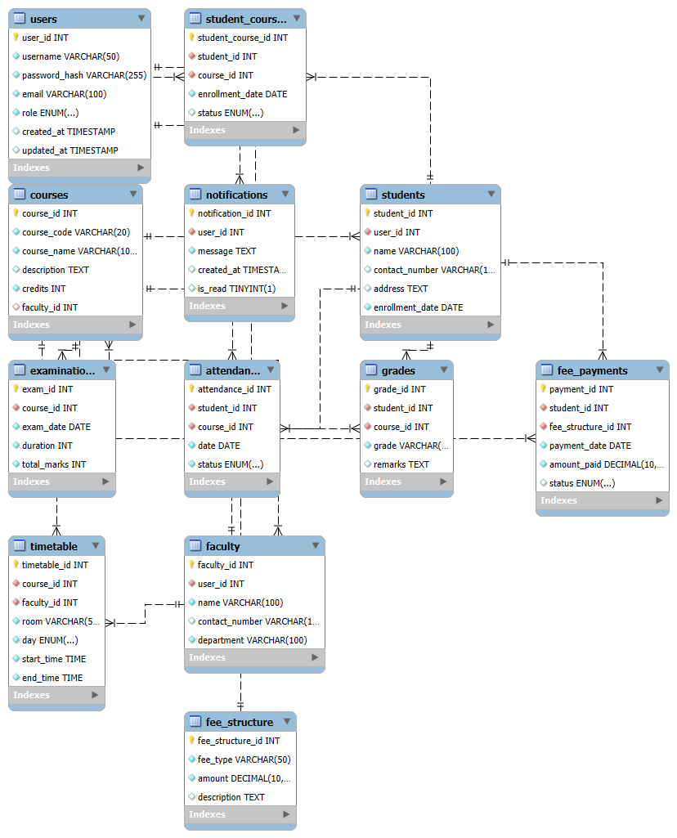

**Normal Froms:**

**1st Normal Form (1NF)**

All tables are already in 1NF because:

* Each table has a primary key.
* All attributes are atomic.

**2nd Normal Form (2NF)**

No partial dependencies exist, so all tables are in 2NF. Below are the tables:

1. **Users**

| **user_id** | **username** | **password_hash** | **email** | **role** | **created_at** | **updated_at** |
| --- | --- | --- | --- | --- | --- | --- |
| 1 | admin01 | hashed_password_1 | [admin@example.com](mailto:admin@example.com) | admin | 2023-09-01 10:00:00 | 2023-09-01 10:00:00 |
| 2 | faculty01 | hashed_password_2 | [faculty@example.com](mailto:faculty@example.com) | faculty | 2023-09-01 10:00:00 | 2023-09-01 10:00:00 |
| 3 | student01 | hashed_password_3 | [student@example.com](mailto:student@example.com) | student | 2023-09-01 10:00:00 | 2023-09-01 10:00:00 |

1. **Students**

| **student_id** | **user_id** | **name** | **contact_number** | **address** | **enrollment_date** |
| --- | --- | --- | --- | --- | --- |
| 1 | 3 | John Doe | 1234567890 | 123 Street, City | 2023-09-01 |

1. **Faculty**

| **faculty_id** | **user_id** | **name** | **contact_number** | **department** |
| --- | --- | --- | --- | --- |
| 1 | 2 | Dr. Smith | 0987654321 | Computer Science |

1. **Courses**

| **course_id** | **course_code** | **course_name** | **description** | **credits** | **faculty_id** |
| --- | --- | --- | --- | --- | --- |
| 1 | CS101 | Introduction to Programming | Basic programming concepts | 3 | 1 |
| 2 | CS102 | Data Structures | Fundamentals of data structures | 4 | 1 |

1. **Student_Courses**

| **student_course_id** | **student_id** | **course_id** | **enrollment_date** | **status** |
| --- | --- | --- | --- | --- |
| 1 | 1 | 1 | 2023-09-05 | enrolled |

1. **Attendance**

| **attendance_id** | **student_id** | **course_id** | **date** | **status** |
| --- | --- | --- | --- | --- |
| 1 | 1 | 1 | 2023-09-06 | present |

1. **Grades**

| **grade_id** | **student_id** | **course_id** | **grade** | **remarks** |
| --- | --- | --- | --- | --- |
| 1 | 1 | 1 | A | Excellent performance |

1. **Examinations**

| **exam_id** | **course_id** | **exam_date** | **duration** | **total_marks** |
| --- | --- | --- | --- | --- |
| 1 | 1 | 2023-12-01 | 120 | 100 |

1. **Fee_Structure**

| **fee_structure_id** | **fee_type** | **amount** | **description** |
| --- | --- | --- | --- |
| 1 | Tuition | 5000.00 | Semester tuition fee |
| 2 | Library | 500.00 | Library maintenance fee |

1. **Fee_Payments**

| **payment_id** | **student_id** | **fee_structure_id** | **payment_date** | **amount_paid** | **status** |
| --- | --- | --- | --- | --- | --- |
| 1 | 1 | 1 | 2023-09-10 | 5000.00 | paid |

1. **Timetable**

| **timetable_id** | **course_id** | **faculty_id** | **room** | **day** | **start_time** | **end_time** |
| --- | --- | --- | --- | --- | --- | --- |
| 1 | 1 | 1 | Room 101 | Monday | 09:00:00 | 10:30:00 |

1. **Notifications**

| **notification_id** | **user_id** | **message** | **created_at** | **is_read** |
| --- | --- | --- | --- | --- |
| 1 | 3 | Welcome to the Institute! | 2023-09-01 10:00:00 | FALSE |

**3rd Normal Form (3NF)**

All tables are already in 3NF since there are no transitive dependencies.

**Boyce-Codd Normal Form (BCNF)**

All tables are already in BCNF since there are no functional dependencies that violate the rules.